Borrower: Mr. Cheat Sopheak and Mdm. Chhay Samen

1. Mr. Cheat Sopheak

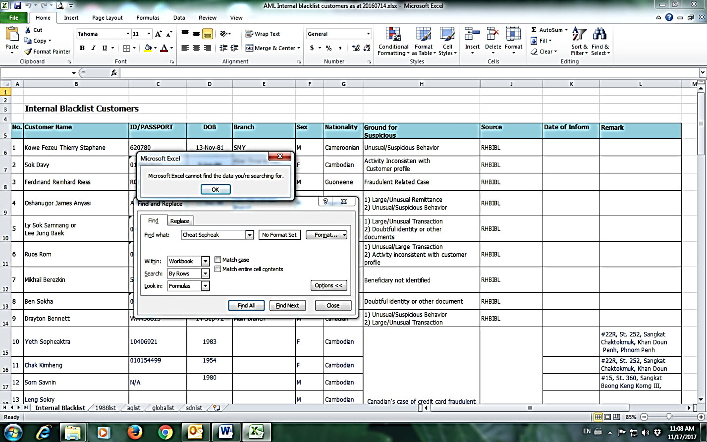

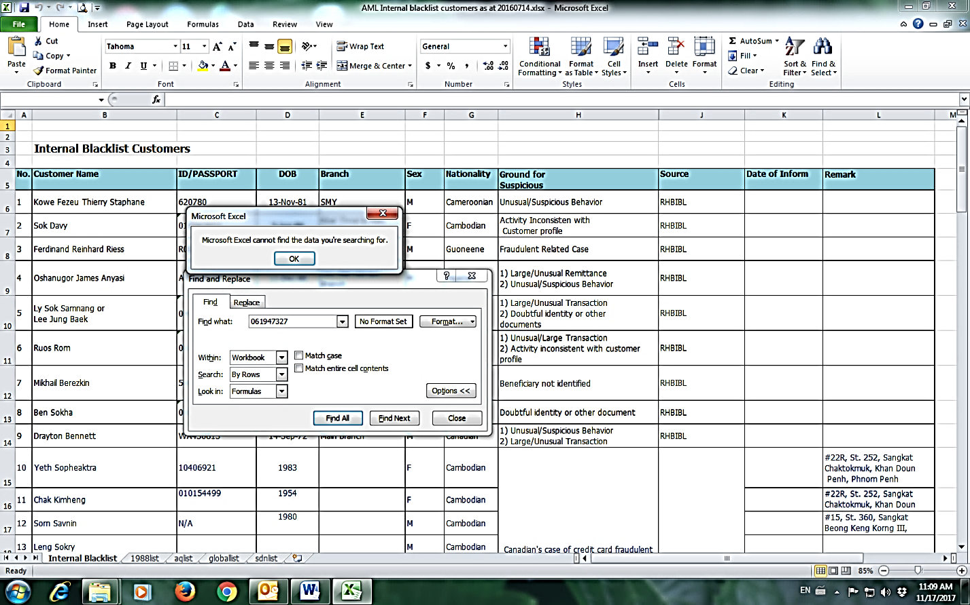

1. Mdm. Chhay Samen

